HEALTH ISSUES OF CANADIAN INDIGENOUS PEOPLE
Meera Abu Hejleh
250928035
Sociology 2206A
Professor Donna Maynard
November 23, 2020

Part A
Research Question
What Problems does the Indigenous Community Face with Health or Wellness?

The Indigenous Community refers to the native peoples who are continuously facing threats related to their ways of knowing, languages, economy, wellbeing, and especially health. The total global population of this community is approx. 600 million. So, the health problem has become a significant concern for this global population of the Indigenous community. This health concern is especially true for the Canadian Indigenous Community, in which child mortality is directly tied to chronic disease, as demonstrated by Wylie and McConkey, (2019). Indigenous people belong largely to developed countries, such as Canada, Australia, America, Oceania, and New Zealand. But, the majority of this community live in the underdeveloped regions of Asia and Africa.
As commented by Jacklin et al. (2017), the repercussions of living in underdeveloped areas and the negative effects that it produces are unemployment, lack of infrastructure, lack in sanitation, spread of illness and diseases are more, lack in education, etc. Often the government ignores the people who are living in the underdeveloped areas, i.e. they are excluded from voting, development of the city, as well as obtaining full protection under the governmental law.

Part B
Step 1: Envision
Health
Indigenous
Wellness
Diseases
Population

Step 2: Books

Reference
D'Arcy, Carl. 1998. "Social Distribution of Health among Canadians." Pp. 73-101 in Health And Canadian Society; Health And Canadian Society."Social Distribution of Health among Canadians."U Toronto Press (https://www-lib-uwo-ca.proxy1.lib.uwo.ca/cgi-bin/ezpauthn.cgi?url=http://search.proquest.com.proxy1.lib.uwo.ca/docview/60035605?accountid=15115).
Description
Reviews the social distribution of health in Canada using secondary data on the distribution of life expectancy, mortality, health problems, disability & activity limitation, risk factors, preventive health practices, & well-being. It is found that regional health status inequalities are diminishing, although the life expectancy of Aboriginal Canadians is still substantially shorter than other groups. Although Canadians are living longer, they suffer more chronic health problems & use more disability days & physician services than in prior periods. Because lower-income groups tend to practice preventive behaviors less than higher-income groups, chronic health problems tend to be socially distributed; ie, although all Canadians have access to good health care, social differences in health exist. It is suggested that combating this problem will require improvement of health promotion & prevention activities, eg, nutrition, housing, interpersonal skills, & other aspects of the physical environment conducive to good health. 23 Figures, 56 References. D. Ryfe

Step 3: Dissertations and Theses

Reference
Maxwell, Krista. 2011. "Making History Heal: Settler-Colonialism and Urban Indigenous Healing in Ontario, 1970s-2010." Order No. NR77864 dissertation, University of Toronto (Canada), Ann Arbor (https://www-lib-uwo-ca.proxy1.lib.uwo.ca/cgi-bin/ezpauthn.cgi?url=http://search.proquest.com.proxy1.lib.uwo.ca/docview/920130153?accountid=15115).

Abstract
This thesis focuses on the interrelationship between Canadian colonial histories and Indigenous healing. I begin by problematizing how colonialism is invoked in contemporary scholarship on Aboriginal health and healing, and arguing for more precise historical methods and a more relational understanding of colonial processes. Historicising Indigenous agency is integral to this analysis. Whilst colonial continuities in contemporary Canadian public policy discourse is an important theme, I also attend to social movements, institutions, professions, and political and economic forces beyond the state.
Indigenous healing as a socio-political movement itself has a history dating at least to the late 1960s. Urban Indigenous healing discourse is characterised by linking present-day suffering to collective historical losses, and valorizing the reclamation of Indigenous identity, knowledge and social relations. Drawing on urban Indigenous social histories from Kenora and Toronto, I consider the urban healing movement as an example of Indigenous resistance influenced by the international decolonization and North American Red Power movements, but which over time has also engaged with dominant institutions, professions, policies, and discourses, such as the concept of trauma. My analysis considers professionals and patients invoking historical trauma as political agents, both responding to and participating in broader shifts in the moral economy. These shifts have created the conditions of possibility for public victimhood to become a viable strategy for attracting attention and resources to suffering and injustice.
The thesis highlights the centrality and complexity of self-determination in urban Indigenous healing, drawing on historical and ethnographic analysis from three southern Ontario cities. I analyse how the liberal multiculturalism paradigm dominant in health policy and health care settings contributes to mental health professionals' failure to recognise Aboriginal clients and issues. I argue that characterising pan-Aboriginal and ethno-national healing as approaches in opposition to one another produces an insufficiently nuanced analysis in the context of urban Indigenous subjectivities and social relations, where both approaches are valuable for different reasons. The thesis urges greater attention to the role of Indigenous languages and local histories, and to the threat which dominant policy discourses on residential schools and mental health pose to the maintenance of distinct ethno-national histories, epistemologies and traditions in urban Indigenous healing.
Reference
Senese, Laura C. 2012. "Exploring Gendered Relationships between Aboriginal Urbanization, Aboriginal Rights and Health." Order No. AAIMR76854 dissertation (https://www-lib-uwo-ca.proxy1.lib.uwo.ca/cgi-bin/ezpauthn.cgi?url=http://search.proquest.com.proxy1.lib.uwo.ca/docview/1322724180?accountid=15115).

Abstract
Aboriginal urbanization has increased dramatically in Canada over the last half century. Aboriginal rights may be an important factor in shaping Aboriginal peoples' experiences of urbanization, as they are largely restricted to those living on reserves. Through their impacts on social determinants of health, these differences in spatial access to Aboriginal rights may have implications for the health of Aboriginal peoples living in urban areas. Using mixed quantitative (statistical analysis of the Aboriginal Peoples Survey) and qualitative (in-depth interviews with Aboriginal women and men in Toronto) methods, this thesis explores relationships between Aboriginal urbanization and Aboriginal rights, focusing on how they may differentially impact the health of Aboriginal women and men living in urban areas. Findings suggest that the perceived lack of respect for Aboriginal rights in urban areas is negatively related to health, and that Aboriginal women and men may experience these impacts differently. Copies of dissertations may be obtained by addressing your request to ProQuest, 789 E. Eisenhower Parkway, P.O. Box 1346, Ann Arbor, MI 48106-1346. Telephone 1-800-521-3042; e-mail: disspub@umi.com

Step 4: Conference Papers

Reference
Currie, Cheryl L. 2010. "Risk and Protective Factors for Addictive Behaviour among Urban Aboriginal Peoples." International Sociological Association (https://www-lib-uwo-ca.proxy1.lib.uwo.ca/cgi-bin/ezpauthn.cgi?url=http://search.proquest.com.proxy1.lib.uwo.ca/docview/743064597?accountid=15115).

Abstract
Background: Indigenous peoples share a disproportionate burden of addictive behaviour with serious implications for health. Social disadvantage is a major risk factor for addictive problems, and many indigenous populations worldwide are in positions of severe socioeconomic disadvantage. The objectives of this study were to examine the extent to which social disadvantage contributes to alcohol, smoking & gambling problems among Aboriginal Canadians living in urban centres, & explore Aboriginal culture as a potential protective factor for these problems. Methods: Data were derived from a national Canadian survey administered in 2006 to Aboriginal, Metis & Inuit adults aged 15 & older. Surveys were administered in 20 Aboriginal languages; the response rate was 80%. Results: Regression models were used to estimate the extent to which addictive behaviour was associated with generated factor scores for Aboriginal cultural continuity & social disadvantage. Results suggest a complex interplay between various addictive behaviours, social disadvantage & the degree to which individuals feel enculturated within Aboriginal, Metis & Inuit traditions. Conclusions: This study promotes a better understanding of the ways in which the social environment drives patterns of addictive behaviour among urban Aboriginal peoples, & identifies potential strengths within Aboriginal cultures that may protect against these problems.

Reference
Shanks, Signa D. 2002. "Discovering Inter-Aboriginal Law in Canada's Constitution." International Sociological Association (https://www-lib-uwo-ca.proxy1.lib.uwo.ca/cgi-bin/ezpauthn.cgi?url=http://search.proquest.com.proxy1.lib.uwo.ca/docview/61780073?accountid=15115).

Abstract
Because of the effect of the doctrine of discovery in Canada's history, most indigenous legal ideas are not part of Canada's adversarial system. But since the creation of the Constitution Act, 1982, and s. 35 of this act, Aboriginals promote cultural traits and treaty arrangements deserving constitutional protection. One might assume that the act therefore aids Aboriginal identity. But new situations demonstrate that, instead of needing to fight against the Crown, an Aboriginal group can have its constitutional protection thwarted by another Aboriginal. I examine some of these Aboriginal-Aboriginal legal battles to observe successes and failures of procedural rules, Canadian common law and different indigenous laws. I hope to recommend changes to courtroom procedure and constitutional interpretation. This research challenges some Pan-Aboriginal assumptions used by the Crown in its previous attempts to demonstrate sovereignty and fiduciary responsibilities toward Aboriginals. The discovery of what I call inter-Aboriginal law represents these circumstances between Aboriginal peoples. A modern interpretation of these problems could help discussion about self-government and help bring traditional Aboriginal legal principles into non-Aboriginal courtrooms. I hope that current Canadian constitutional jurisprudence can be complementary, rather than a hindrance, to traditional and modern Aboriginally based legal methods. Constitutional arguments involving Aboriginal peoples will not be easy in the near future. Scrutinizing constitutional legal battles between Aboriginals provides a way to confront jurisprudential, social and political assumptions that need modification to minimize disagreements between Aboriginals and non-Aboriginals in the future. Inter-Aboriginal law represents a new constitutional doctrine to be discovered.

Step 5: Journal Articles

Reference 1
Belayet, Hossain, and Laura Lamb. 2020. "Cultural Attachment and Wellbeing among Canada’s Indigenous People: A Rural Urban Divide." Journal of Happiness Studies 21(4):1303-1324 (https://www-lib-uwo-ca.proxy1.lib.uwo.ca/cgi-bin/ezpauthn.cgi?url=http://search.proquest.com.proxy1.lib.uwo.ca/docview/2223139433?accountid=15115). doi: http://dx.doi.org.proxy1.lib.uwo.ca/10.1007/s10902-019-00132-8.

Abstract
The relationship between cultural attachment and mental wellbeing among Canada’s Indigenous population is explored with data from the 2012 Aboriginal Peoples Survey. Cultural attachment is assessed by involvement in traditional activities and Indigenous language. Ordered profit models are used to determine the factors associated with wellbeing. The results suggest an urban–rural divide with cultural attachment associated with higher levels of wellbeing for Indigenous Canadians living in rural areas. The results are expected to be of interest to policy makers in countries with significant Indigenous populations whom tend to have higher frequencies of psychological wellbeing issues, such as Canada, Australia and the United States.

Reference 2
Horrill, Tara C., Janice Linton, Josée G. Lavoie, Donna Martin, Allison Wiens and Annette S. H. Schultz. 2019. "Access to Cancer Care among Indigenous Peoples in Canada: A Scoping Review." Social Science & Medicine 238:1 (https://www-lib-uwo-ca.proxy1.lib.uwo.ca/cgi-bin/ezpauthn.cgi?url=http://search.proquest.com.proxy1.lib.uwo.ca/docview/2317026110?accountid=15115). doi: http://dx.doi.org.proxy1.lib.uwo.ca/10.1016/j.socscimed.2019.112495.

Abstract
The inequities in access to healthcare documented and experienced by Indigenous peoples in Canada are startling given Canada's publicly funded and 'equally accessible' healthcare system, however little is known about access to cancer care, and barriers to accessing cancer care in particular. We conducted a scoping review to identify what is known about barriers to accessing cancer care among Indigenous peoples in Canada (including barriers to accessing cancer services, and barriers to receiving optimal care once those services were accessed), and to identify where along the cancer continuum (screening, diagnosis, treatment, etc.) these barriers are located. We searched SCOPUS, EBSCOhost, Google Scholar, Ovid MEDLINE and Ovid EMBASE for studies published between 1996 and 2019 that examined access to cancer care for Indigenous peoples in Canada; 36 studies were included in our analysis. Our review indicates that Indigenous peoples face barriers to accessing care at the individual level (factors at the level of the individual patient or healthcare provider (HCP) that impede access to cancer care), at the systems level (factors stemming from the healthcare system and its structure), and at the structural level (factors that are embedded within and systematically produced political, historical, social or economic structures). While barriers to accessing cancer, care were found throughout the trajectory, there remains a disproportionate focus on access to cancer screening. Moreover, some barriers to accessing cancer care, such as racism, discrimination and lack of culturally safe care, although rooted in structural factors, were inconsistently framed as individual and/or systems factors. This suggests that while there is growing awareness of the impact that racism and discrimination have on access to cancer care at the individual level for example, there remains a lack of understanding of how these issues are linked with systemic and structural issues.

Reference 3
Stephenson, Peter H. 1997. "Environmental Health Perspectives on the Consequences of an Ideology of Control in "Natural" Systems." La Revue Canadienne De Sociologie Et d'Anthropologie/The Canadian Review of Sociology and Anthropology 34(3):349-367 (https://www-lib-uwo-ca.proxy1.lib.uwo.ca/cgi-bin/ezpauthn.cgi?url=http://search.proquest.com.proxy1.lib.uwo.ca/docview/60070500?accountid=15115).

Abstract
Examines epistemological assumptions of environmental control that underlie Canadian anthropological perspectives with respect to medical anthropology & ethnography of indigenous peoples in the northern resource extraction zones. It is argued that health issues are typically treated as individual rather than community concerns, which are largely divorced from surrounding environmental factors. Environmental & community issues, eg, pollution, loss of biodiversity, & overmedication, must become an integral part of medical anthropology. The case of increasing bacterial resistance to antibiotics illustrates human inability to control nature & the need for a new health practice paradigm. 51 References. Adapted from the source document.

Reference 4
Tang, Sannie Y., and Annette J. Browne. 2008. "'Race' Matters: Racialization and Egalitarian Discourses Involving Aboriginal People in the Canadian Health Care Context." Ethnicity & Health 13(2):109-127 (https://www-lib-uwo-ca.proxy1.lib.uwo.ca/cgi-bin/ezpauthn.cgi?url=http://search.proquest.com.proxy1.lib.uwo.ca/docview/61675818?accountid=15115). doi: http://dx.doi.org.proxy1.lib.uwo.ca/10.1080/13557850701830307.

Abstract
The major purpose of this paper is to examine how 'race' and racialization operate in health care. To do so, we draw upon data from an ethnographic study that examines the complex issues surrounding health care access for Aboriginal people in an urban center in Canada. In our analysis, we strategically locate our critical examination of racialization in the 'tension of difference' between two emerging themes, namely the health care rhetoric of 'treating everyone the same,' and the perception among many Aboriginal patients that they were 'being treated differently' by health care providers because of their identity as Aboriginal people, and because of their low socio-economic status. Contrary to the prevailing discourse of egalitarianism that paints health care and other major institutions as discrimination-free, we argue that 'race' matters in health care as it intersects with other social categories including class, substance use, and history to organize inequitable access to health and health care for marginalized populations. Specifically, we illustrate how the ideological process of racialization can shape the ways that health care providers 'read' and interact with Aboriginal patients, and how some Aboriginal patients avoid seeking health care based on their expectation of being treated differently. We conclude by urging those of us in positions of influence in health care, including doctors and nurses, to critically reflect upon our own positionality and how we might be complicit in perpetuating social inequities by avoiding a critical discussion of racialization. Adapted from the source document.

Reference 5
Tutty, Leslie M., Radtke H. Lorraine, Thurston Wilfreda E (Billie), Kendra L. Nixon, Ursel E. Jane, Christine A. Ateah and Mary Hampton. 2020. "The Mental Health and Well-being of Canadian Indigenous and Non-Indigenous Women Abused by Intimate Partners." Violence Against Women 26(12-13):1574-1597 (https://www-lib-uwo-ca.proxy1.lib.uwo.ca/cgi-bin/ezpauthn.cgi?url=http://search.proquest.com.proxy1.lib.uwo.ca/docview/2435729388?accountid=15115). doi: http://dx.doi.org.proxy1.lib.uwo.ca/10.1177/1077801219884123.

Abstract
Intimate partner violence (IPV), mental health, disabilities, and child abuse history were examined for 292 Indigenous compared with 295 non-Indigenous Canadian women. IPV was assessed by the Composite Abuse Scale and mental health by the Symptom Checklist-10, Center for Epidemiological Studies–Depression 10, the Posttraumatic Stress Disorder (PTSD) Checklist, and Quality of Life Questionnaire. Scores did not differ nor were they in the clinical ranges for the two groups. In a MANCOVA on the mental health/well-being scales, with IPV severity as a covariate, only disability was significantly associated with more severe mental health symptoms. Suggestions for service providers are presented.

Step 6: Backwards

Reference
Adelson, Naomi. 2005. "The Embodiment of Inequity: Health Disparities in Aboriginal Canada." Canadian Journal of Public Health = Revue Canadienne De Sante Publique 96 Suppl 2:S45-S61 (https://www-lib-uwo-ca.proxy1.lib.uwo.ca/cgi-bin/ezpauthn.cgi?url=http://search.proquest.com.proxy1.lib.uwo.ca/docview/68441632?accountid=15115).

Abstract
Health disparities are, first and foremost, those indicators of a relative disproportionate burden of disease on a particular population. Health inequities point to the underlying causes of the disparities, many if not most of which sit largely outside of the typically constituted domain of "health". The literature reviewed for this synthesis document indicates that time and again health disparities are directly and indirectly associated with social, economic, cultural and political inequities; the end result of which is a disproportionate burden of ill health and social suffering upon the Aboriginal populations of Canada. In analyses of health disparities, it is as important to navigate the interstices between the person and the wider social and historical contexts as it is to pay attention to the individual effects of inequity. Research and policy must address the contemporary realities of Aboriginal health and well-being, including the individual and community-based effects of health disparities and the direct and indirect sources of those disparities.
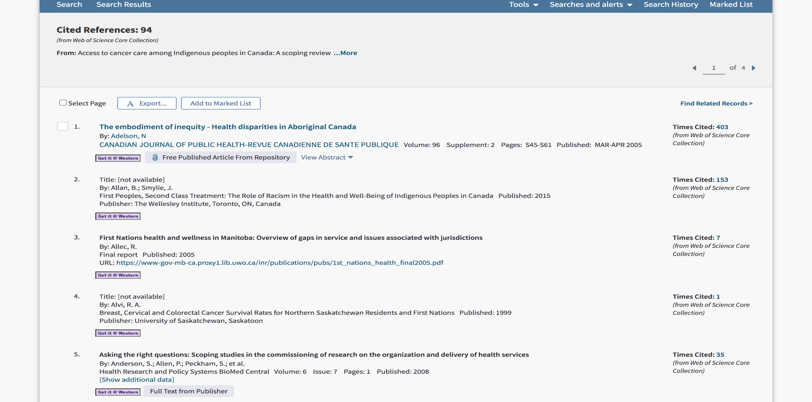

Step 7: Forward

Reference
Marie-Claude, Tremblay et al. 2020. “Improving Cultural Safety of Diabetes Care in Indigenous Populations of Canada, Australia, New Zealand and the United States: A Systematic Rapid Review.” 44(7):670–78. (http://apps.webofknowledge.com.proxy1.lib.uwo.ca/full_record.do?product=WOS&search_mode=GeneralSearch&qid=2&SID=6DcVRKkEhmMCmlIkBsS&page=1&doc=2)
Abstract
Objectives: Our aim in this study was to identify interventions that improve cultural safety for Indigenous people living with diabetes in the health-care setting, and their potential impact on patients and health-care professionals.
Methods: Using a systematic approach, we conducted a rapid review of quantitative, qualitative and mixed studies between January 2000 and February 2018 in MEDLINE, Embase, Web of Science, ERIC, CINAHL and PsyclNFO. Two reviewers independently identified, selected and reviewed studies relating to cultural safety in diabetes care for Indigenous populations in Canada, New Zealand, Australia and the United States.
Results: Of the 406 studies identified, we retained 7 articles (2 strong quality, 5 moderate quality) for analysis. The included studies evaluated 3 main types of strategies to improve cultural safety: educating health professionals, fostering culturally safe practices by modifying clinical environments and integrating Indigenous health professionals in the workforce. Studies showed that culturally safe interventions had positive effects on clinical outcomes for patients, increased patient satisfaction and health professional confidence in providing care as well as patient access to health care.
Conclusions: Although based on a small number of studies, this review establishes moderate evidence that interventions to improve cultural safety can have positive effects on treatment of diabetes in Indigenous populations. Further research with stronger study designs should be conducted to further validate our conclusions. (C) 2019 Canadian Diabetes Association.

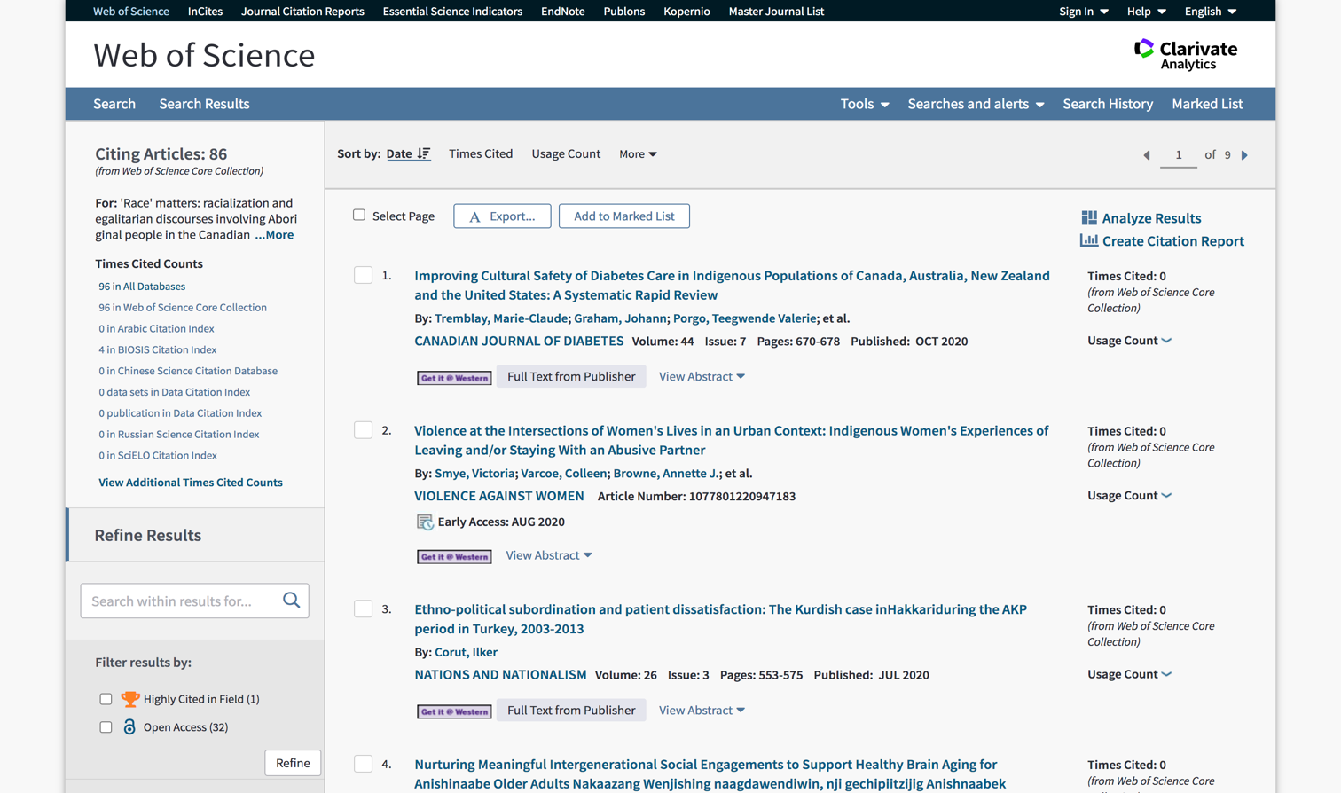

Step 8: Reflecting on the Process

Having comprehended between the abstract and research question, I noticed many similarities in my research arguments. Although I used the same key terms such as health, population, and diseases which helped me narrow down the major factors within the indigenous community, I used the word aboriginal instead of indigenous in order to increase my findings for the research. Furthermore, the critical issues for the Canadian indigenous community is socioeconomic status (SES) in regards to a rural-urban divide in mental wellbeing and cultural attachment. Since some areas in the indigenous community are exposed to a weaker socioeconomic structure which affects the language, mental wellbeing, and financial stability of the people. I believed the negative impacts would be a lack of infrastructure, unemployment rates, lack in sanitation, and the spread of diseases. As referred policy makers like the government tend to ignore undeveloped population such as the indigenous community. Another argument from the abstract is that the larger the indigenous population the greater the chance for mental illnesses within the community. Nevertheless, I believe I measured the issues of the indigenous people quite accurately according to the article and abstract.

Part C
Summary
Canadian Indigenous people, especially the children and youth from this community, suffer from chronic disease and heart problems due to poor health conditions that adversely affect their livelihood (in the case of children, their growth) and adulthood. They are more likely than non-indigenous people to have chronic and mental illnesses such as chronic kidney disease, heart problems, diabetes, depression, and suicide. Canadian Indigenous children are deprived of adequate food sources. As a result, they substantially suffer from malnutrition and tuberculosis. The fundamental reason behind Canadian Indigenous people’s poor health condition is their standard of living that is considered very poor compared to other Canadians. However, the Canadian Government has taken some significant initiatives to improve their health conditions.
As forwarded by Bates (2017), this study depicts the emotional as well as the adverse mental effects on female survivors of revenge porn. To date, none of the academic studies have focused primarily on the mental effects of health in the cases of revenge porn. In this study, in-depth analysis on qualitative interviews is conducted from February 2014 to January 2015, consisting of 18 female survivors of revenge porn. Furthermore, an inductive analysis is conducted that revealed the experiences of the potential participants on the basis of trust issues, posttraumatic stress disorders, suicidal thoughts, anxiety, depression as well as other mental effects of health. These results depict the severity of revenge porn; it is a devastating impact on the mental health of the survivors, along with the similarities in between revenge porn as well as sexual assault.
As the research by Watson et al. (2017) demonstrates, several literature studies confirm the various negative effects of economic insecurity towards mental health, but at the same time ignores the implications that are possible towards repeated insecurities. This study questions the ways in which an individual’s history of economic insecurity matters in psychological distress through contrasting implications of both the models. Consistent towards the literature of health capital, the Healing model depicts psychological distress to be a stock variable that is affected by the life event shocks, along with the previous events that have less impact as compared with the recent shocks. Additionally, the Breaking Point Model takes into consideration the high distress levels representing the life states distinct shift that occurs if past life’s stress accumulation exceeds the critical value. By utilising the five cycles of Canadian National Population Health Survey information from the year 2000 to 2009, the impacts of previous shocks of economic insecurity on the present psychological distress could help in distinguishing between these two hypotheses. In this study, a sample of 1775 males along with 1883 females who are aged between 25-64 years are considered and a strong healing effect is found for one-time shock of economic insecurity. For the males, only a current occurrence of one-time economic insecurity is predicted for higher psychological distresses. Furthermore, the working aged adults tend to be recovered from the previous accumulated experiences related to economic insecurity if they would have been secured economically. In short, the Breaking Point Hypotheses is consistent and depicts that the males experience 3-4 cycles of present insecurity than the females. This research might prove valuable when investigating adverse psychological and physical wellbeing.

References

Bingham, B., Moniruzzaman, A., Patterson, M., Distasio, J., Sareen, J., O’Neil, J., & Somers, J. M. (2019). Indigenous and non-Indigenous people experiencing homelessness and mental illness in two Canadian cities: A retrospective analysis and implications for culturally informed action. BMJ open, 9(4), e024748. Retrieved on: 9 October 2020; retrieved from: https://scholar.google.com/scholar?output=instlink&q=info:DF3f274TQg4J:scholar.google.com/&hl=en&as_sdt=0,5&as_ylo=2016&scillfp=7945087715933674557&oi=lle

Jacklin, K. M., Henderson, R. I., Green, M. E., Walker, L. M., Calam, B., &Crowshoe, L. J. (2017). Health care experiences of Indigenous people living with type 2 diabetes in Canada. Cmaj, 189(3), E106-E112. Retrieved on: 9 October 2020; retrieved from: https://www.cmaj.ca/content/cmaj/189/3/E106.full.pdf

Wylie, L., &McConkey, S. (2019). Insiders’ insight: discrimination against indigenous peoples through the eyes of health care professionals. Journal of racial and ethnic health disparities, 6(1), 37-45. Retrieved on: 9 October 2020; retrieved from: https://link.springer.com/article/10.1007/s40615-018-0495-9

Watson, B., & Osberg, L. (2017). Healing and/or breaking? The mental health implications of repeated economic insecurity. Social science & medicine, 188, 119-127. Retrieved from: https://www.sciencedirect.com/science/article/abs/pii/S0277953617304185

Bates, S. (2017). Revenge porn and mental health: A qualitative analysis of the mental health effects of revenge porn on female survivors. Feminist Criminology, 12(1), 22-42. Retrieved from: https://www.biscmi.org/wp-content/uploads/2016/08/Revenge-Porn-and-Mental-Health-A-Qualitative-Analysis-of-the-Mental-Health-Effects-of-Revenge-Porn-on-Female-Survivors.pdf

